


SOFTWARE DESIGN SPECIFICATION
WEB DEVELOPMENT
COLLEGEHUB

Created By: | Prajakta Pattanaik | Approved By: | <Domain Lead Name>
Created On: | 20-05-2026 | Approved On: | DD-MMM-YYYY

Page left blank intentionally

INDEX
1 PURPOSE 2
2 PROJECT SCOPE 2
3 SYSTEM OVERVIEW 2
4 DESIGN CONSIDERATIONS 2
4.1 Requirements 3
4.2 Assumptions 3
4.3 Dependencies 3
5 SYSTEM ARCHITECTURE 3
5.1 Architectural Strategies 4
5.2 Structure & Relationships 4
6 DETAILED DESCRIPTION OF COMPONENTS 4
7 INTEGRATION 5
8 APPENDICES 1
8.1 Appendix A – Detailed Description of Components 1

General Instructions for using the Live Project POC Document
- This template and the subsequent document created using this template is a confidential document and is the intellectual property of Cloud Counselage Pvt. Ltd. Circulating it outside of the organisation without the consent of Cloud Counselage Pvt. Ltd. is the breach of company policies and will lead to legal actions
- The Design Specification of a software forms the basis of development of software
- The text between inequality (< >) is to be replaced by relevant text
- Please remove the yellow highlight on the Text between the inequality (< >). This is done to help you notice the text to be changed/replaced
- The text in italics highlighted in grey is just for reference and should be removed after adding the relevant text

PURPOSE
This document is created based on the requirement specification document. The purpose of this Software Design Specification (SDS) Document is to break down the project into components to describe in detail what the purpose of each component is and how it will be implemented. The SDS will also serve as a tool for verification and validation of the final product.

PROJECT SCOPE
The scope of the CollegeHub includes its distinct features, its benefits, and its limitations. The system's distinct features allow it to help students search, explore, and compare colleges efficiently by using a web-based platform, search filters, and a PostgreSQL database. The system enables the user to find suitable colleges based on their preferences and access detailed college information quickly and easily.

SYSTEM OVERVIEW
This section will provide an outline of the various components and subsystems of CollegeHub
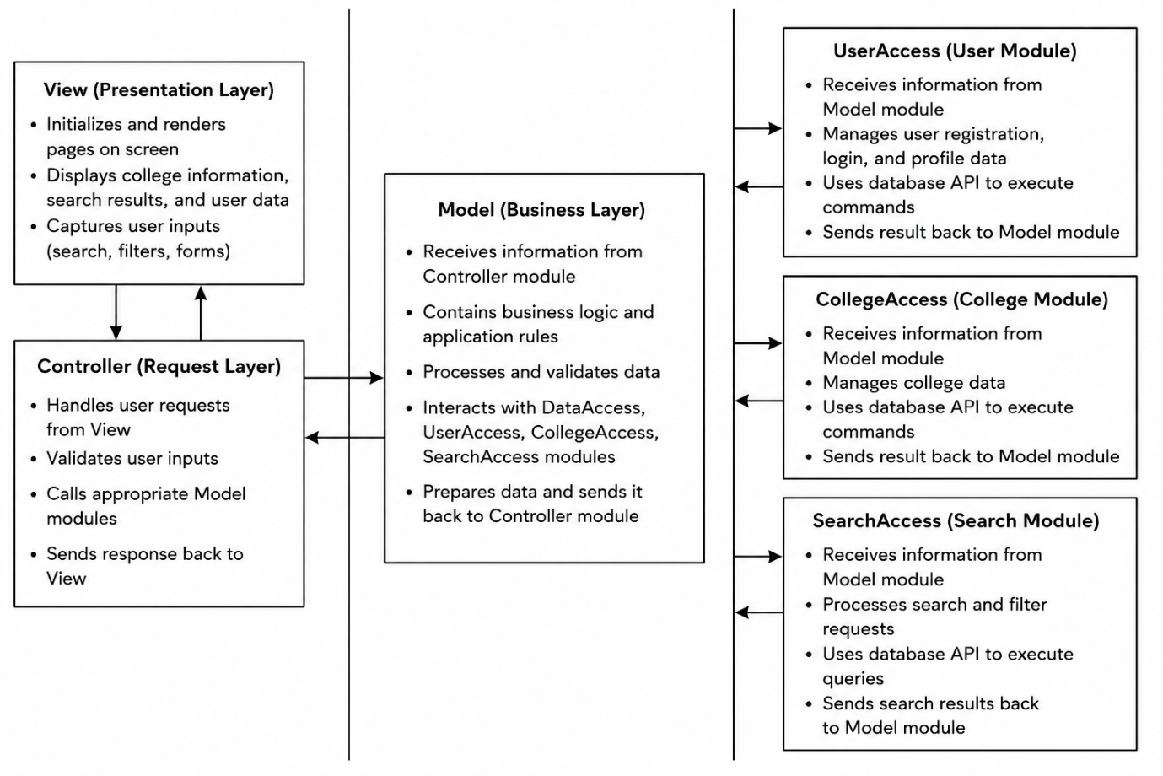

DESIGN CONSIDERATIONS
This section describes requirements, assumptions and dependencies to be addressed to devise a complete design solution.

Requirements
The list of components -
- Hardware Requirements: Client Side: Processor: Intel i3 or above, RAM: 4 GB or more, Storage: 1 GB free space, Internet Connection. Server Side: Processor: Dual Core or above, RAM: 2 GB or more, Storage: 10 GB free space.
- Software Requirements: Operating System: Windows 10/11 or Linux, Frontend: HTML5, CSS3, JavaScript, Backend: Node.js, Express.js, Database: PostgreSQL, Development Tools: VS Code, Git, Browser: Chrome/Edge/Firefox.

Assumptions
The list of components-
Users have internet access, college information stored in the database is accurate and updated, users possess basic knowledge of website navigation, and the server remains available during usage.

Dependencies
- The list of components -
Node.js – Runtime environment
- Express.js – Backend framework
- PostgreSQL – Database management system
- bcrypt – Password encryption
- HTML/CSS/JavaScript – Frontend technologies
- Fetch API – Communication between frontend and backend

SYSTEM ARCHITECTURE
The software system architecture refers to the logical organization of a distributed system into software components. It defines how components of a software system are assembled, their relationship and communication between them. It serves as a blueprint for software application and development basis for developer team. An effective architecture serves as the conceptual glue that holds every phase of the project together for all of its stakeholders, enabling agility, time and cost savings, and early identification of design risks.
The Software architecture:
- Defines structure of a system
- Defines behaviour of a system
- Defines component relationship
- Defines communication structure
- Balances stakeholder’s needs
- Influences team structure
- Focuses on significant elements
- Captures early design decisions

Below some important characteristics which are commonly considered are explained.
Operational Architecture Characteristics:
- Availability
- Performance
- Reliability
- Low fault tolerance
- Scalability

Structural Architecture Characteristics:
- Configurability
- Extensibility
- Supportability
- Portability
- Maintainability

Cross-Cutting Architecture Characteristics:
- Accessibility
- Security
- Usability
- Privacy
- Feasibility

Architectural Strategies
Presentation Layer (Frontend)
- Home Page
- College Listings
- Search and Filter Interface
- Login and Registration Pages
- User Interaction Components
Controller Layer
- Request Handling
- Input Validation
- Routing and Navigation Control
- Communication between Frontend and Backend
Business Logic Layer (Model)
- College Search Logic
- Filtering Logic
- User Authentication Logic
- Data Processing and Validation
User Management Module
- User Registration
- User Login
- Password Encryption (bcrypt)
- Profile Management
College Management Module
- College Information Storage
- College Data Retrieval
- Featured Colleges Management
Search and Recommendation Module
- College Search
- Course Filtering
- Result Processing
Database Layer
- PostgreSQL Database
- User Data Storage
- College Data Storage
Deployment and Hosting Layer
- Node.js Runtime Environment
- Express.js Server
- Hosting Platform
- Database Connectivity

Structure & Relationships
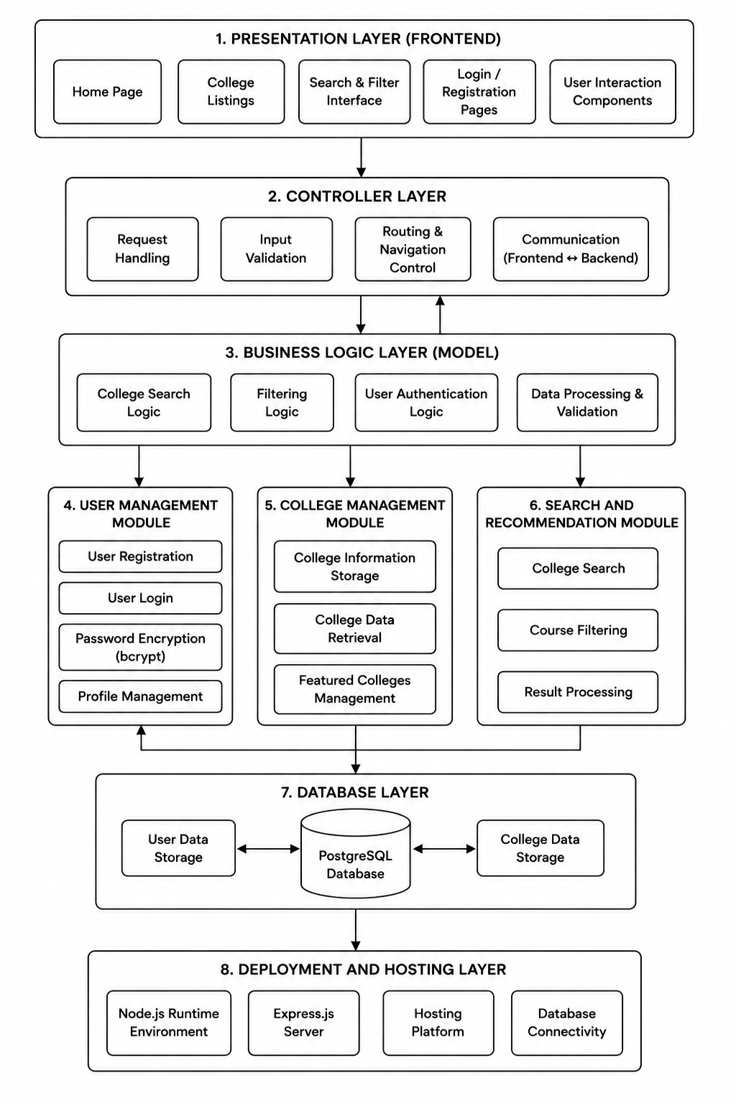

DETAILED DESCRIPTION OF COMPONENTS
For detailed description of the components, please refer Appendix A – Detailed Description of Components

The below template will be used to specify the details of all the components
Table 1: Detailed Design Specification Template
Identification | The unique name for the component and the location of the component in the system.
Type | A module, a subprogram, a form, a data file, a control procedure, a class, etc.
Purpose | Function and performance requirements implemented by the design component, including derived requirements. Derived requirements are not explicitly stated in the SRS - but are implied or adjunct to formally stated SDS requirements.
Subordinates | The internal structure of the component, the constituents of the component, and the functional requirements satisfied by each part.
Dependencies | How the component’s function and performance relate to other components. How this component is used by other components. The other components that use this component. Interaction details such as timing, interaction conditions (such as order of execution and data sharing), and responsibility for creation, duplication, use, storage, and elimination of components.
Interfaces | Detailed description of all external or internal interfaces as well as of any mechanism for communicating through messages, parameters, or common data areas. All error messages and error codes should be identified. All screen formats, interactive messages, and other user interface components (originally defined in the SRS) should be given here.
Resources | A complete description of all resources (hardware or software) external to the component but required to carry out its functions.
Processing | A full description of the functions presented in the Function subsection. Pseudocode can be used to document algorithms, equations, and logic.
Data | For the data internal to the component, describes the representation method, initial values, use, semantics, and format.

INTEGRATIONS
The CollegeHub System will interface with a PostgreSQL database to store and manage college information and user data. The database will be accessed through the backend application developed using Express.js and Node.js. The system will retrieve, update, and manage records related to colleges, courses, and registered users.
• PostgreSQL will be used as the primary Database Management System (DBMS) for storing and retrieving application data.
• Node.js will be used as the runtime environment to execute server-side code and manage communication between the frontend and database.
• Express.js will be used to develop RESTful APIs that handle requests, process business logic, and interact with the PostgreSQL database.
• bcrypt will be used to provide password encryption and secure user authentication functionality.
• HTML, CSS, and JavaScript will be used to develop the user interface and provide an interactive user experience.
• The Fetch API will be used to enable communication between the frontend and backend services for retrieving and displaying college information.
• The CollegeHub System may be deployed on a cloud hosting platform, enabling users to access the application through a web browser without requiring additional software installation.

APPENDICES

Appendix A – Detailed Description of Components
Identification | LoginScreen
Type | Web Page / UI Component
Purpose | The Login Screen ensures that only registered users can access personalized features of the CollegeHub system.
Subordinates | This screen contains links to the following pages:  • Home Page  • Registration Page  • Featured Colleges Page
Dependencies | The following pages link to this screen:  • Home Page  • Registration Page
Interfaces | The screen contains username/email and password input fields, Login button, and Register link. It is designed to be responsive across desktop and mobile devices.
Resources | Database Access Requirements: access to the Users table in the PostgreSQL database for validating user credentials.
Processing | The system validates user input, encrypts passwords using bcrypt, compares credentials with stored records, and grants access upon successful authentication.
Data | Username/Email, Password, Authentication Status, User Profile Information.

Identification | HomeScreen
Type | Web Page / UI Component
Purpose | Provides users with an overview of the CollegeHub system and access to college search, featured colleges, and user authentication features.
Subordinates | • Featured Colleges Section  • Search Section  • Login Screen  • Registration Screen
Dependencies | • College Search Screen  • College Details Screen  • Login Screen
Interfaces | Navigation bar, search bar, featured colleges cards, and footer.
Resources | Access to college information stored in the PostgreSQL database.
Processing | Displays featured colleges and redirects users to other pages based on their selections.
Data | College names, locations, courses, rankings, and featured college information.

Identification | CoursesScreen
Type | Web Page / UI Component
Purpose | Allows users to browse and search for courses offered by different colleges.
Subordinates | • Home Screen  • College Details Screen  • Login Screen
Dependencies | • Home Screen  • Navigation Menu  • Search Results Screen
Interfaces | Navigation bar, search bar, courses cards, and footer.
Resources | Access to courses stored in the PostgreSQL database.
Processing | Displays courses based on the search made.
Data | Course Name, Course Category, Degree Type, Duration

Identification | CollegeDetailsScreen
Type | Web Page / UI Component
Purpose | Displays detailed information about a selected college.
Subordinates | • Featured Colleges Section  • Search Section  • Login Screen  • Registration Screen
Dependencies | • College Management Module
Interfaces | Navigation bar, search bar, featured colleges cards with details, and footer.
Resources | Access to college information stored in the PostgreSQL database.
Processing | Retrieves and displays information for the selected college.
Data | College names, locations, courses, rankings, and other college information.

